National College of Computer Studies
Paknajol, Kathmandu

Project Report
of
Software Engineering
on
Library Management System

Submitted By: Submitted To
Anjali Balami Ms. Sachita Maharjan
Rejina Maharjan
Ritina Maharjan
Sanish Maharjan
BIM 6th Semester “A”

Date of Submission: 7th July, 2023
Table of Contents
1. Abstract 1
2. Acknowledgement 2
3. Introduction 3
3.1 Project Introduction 3
3.2 Existing system overview 3
3.3 Statement of Problem 3
3.4 Objective 3
3.5 Limitation 3
4. Literature review 4
5. Research Methodology 5
5.1 Feasibility Analysis 5
5.1.1 Technical Feasibility 5
5.1.2 Social and Operational Feasibility 5
5.1.3 Economic Feasibility 5
5.2 Software Development Methodology 5
5.3 Functional and Non-functional Requirement Specification 6
5.3.1 Functional Requirement Specification 6
i. For Admin Module Features: 6
ii. For Students Module Features: 6
5.3.2 Non- functional Requirement Specification 6
6. Software Development 7
6.1 Use case Diagram 7
5.2 Activity Diagram 8
5.3 Sequence Diagram 9
5.4 State Diagram 10
5.5 Data-Flow Diagram 11
7. Database design 12
7.1 ER Diagram 12
7.2 Data dictionary 13
8. Gantt Chart 14
9. Implementation of code: 15
10. Screenshots: 17
10. Conclusion 20
References

List of Figures
Figure 5. 1 Waterfall Model 5

Figure 6. 1: Use Case 7
Figure 6. 2: Activity Diagram 8
Figure 6. 3: Sequence Diagram 9
Figure 6. 4 State Diagram 10
Figure 6. 5 Data Flow Diagram 11

Figure 7. 1 ER Diagram 12
Figure 7. 2 Admin Information 13
Figure 7. 3 Author Information 13
Figure 7. 4: Book Information 13
Figure 7. 5 Category Information 13
Figure 7. 6 Issued Books Details 14
Figure 7. 6 Student Details 14

Figure 8. 1 Gantt Chart 14

1. Abstract

We have spoken about the project's "Library Management System" introduction. The company's performance will be much enhanced if pay leave and other issues are well managed. In the current system overview, we have discussed the merits and disadvantages of both a manual and an online system. Our statement of issue said that a manual system may take a long time and a lot of work to operate. The primary goal of this project is to move from a paper-based system to an online one, therefore saving both time and effort. Software maintainability and its sub-attributes were discussed in the literature review section. Design patterns and concepts have also been discussed, as well as numerous UML diagrams such as class diagrams and use-case diagrams. We have also spoken about research methods like feasibility analysis and functional and nonfunctional requirements. In addition to writing code, students are expected to provide a snapshot of their work.

Acknowledgement

I would like to convey my sincere gratitude and appreciation to all those who gave me the possibility to complete this report. A Special thanks to my supervisor Ms.Sachita Maharjan for providing his valuable comments, guidance and suggestions throughout the course of the project. I would like to specially thank her for his constant motivation to work hard and providing us enough information for the fulfillment if the project as well as the report.
I also thank our college, National College of Computer Studies (NCCS) for providing a platform and necessary arrangements for the completion of project work.Once again, I extend my deepest appreciation to all those who have contributed to this report. Your commitment and assistance have been indispensable, and I am truly grateful for the opportunity to work with the guidance of such remarkable individuals.

Sincerely,
Anjali Balami
Rejina Maharjan
Ritina Maharjan
Sanish Maharjan

3. Introduction

3.1 Project Introduction

A library is a place where a huge collection of books and resources are available and can be accessible by the users. It enhances the dissemination of knowledge and spiritual civilization among the students. The tons of books and research works are captivating the user to improvise their knowledge in all perspectives. To examine any data then they have to refer the
notebooks. At the same time while distributing the books to the user they have to enter into the notebook where they need to represent the book id, distribution and renewal date, and user id. Therefore, it causes a monotonous among staff. In this technological era, we build a “Library Management System “.It is a system that reduces a work of librarians. It will manage, organize and oriented the library task. It support librarian to add, update details, view, delete from the library stock.

3.2 Existing system overview
Traditionally, library systems are used manually. Forms are given to the Librarian and they fill them of using pens. The manual library system is very time consuming and a tiresome task. The primary complaint of some Librarians with this manual system is the tiresome task of searching records. The fast changed of technology ascribe a lot to the development of the library system. The computerized library system may help the academe (Patulada, 2023).

3.3 Statement of Problem
There are many problems while recording data and information in hardcopy. Librarians find difficult to search data of a library user, as the data are stored in different parts and takes long time to retrieve data. Data could be misplaced due to human error and data can be easily stolen. While issuing and taking back books, locating and updating index card index is slow. Manual systems are unable to store large amount of data efficiently. Library Management System enables Librarians to keep track of available books. It helps librarians to keep the track of library user easily. It makes easier to track those who have borrowed books and have not returned to them. It saves time and data retrieving will be faster.

3.4 Objective

- To offer free book reading facilities to all.
- To grow healthy readership at all levels.
- To disseminate knowledge on all subjects and topics.
- To collect and preserve all documents having research value and local importance.
- To microfilm records and books for future reference.

3.5 Limitation

- Costly and Expensive
- Speed of access
- Risk of computer virus

4. Literature review
Within this chapter the researches presented the reviews of literature and systems that are greatly related to our proposed system, with this we will understand the past studies for us to develop a lot more effective and efficient system.

- Electronic library management Systems In accordance to the study of Robertson (2004), Library management system (LMS) known as an automated Library System is software that is developed to deal with the basic functions of a Library, and provides a complete solution for the administration of a library’s technical, economic and social functions and services to the users. These functions range from; tracking the assets held by the library, managing book and user records, through to supporting the daily work over. These systems are used in almost all libraries large and a small once (Patulada, 2023).

- Library reservation system Library is a substantial part of the academic sector as well as some professional sectors too like, Advocacy etc. The effectiveness of a library relies on how the book and other materials are organized and how easily one can get the books that they preferred. Mainly, what we see nowadays is manual library management system whose method of operation is very much unsettled. What we are doing is that we are proposing a computerized library management system, which provides better and efficient service to the library members. This software is meant to transform the unsettled manual system to a more adequate computerize system. This application can be used conveniently in educational institute and certain professional districts also. This application presumes that the user doesn’t possess the right to alter information about books. In accordance to Yao ‘s (2013), background of the study (Patulada, 2023)

5. Research Methodology

Feasibility Analysis

5.1.1 Technical Feasibility
During the study, it is concluded that this system is technically feasible because there will be no much trouble and difficulty in getting the required resources for the development and maintenance of the system. As well as all the resources for software and hardware development is already available.

5.1.2 Social and Operational Feasibility
The proposed library borrowing system study is socially and operationally feasible for the organization because the system is developed with the required wants and needs in order to easily understand and manipulate the systems functions, this system made sure that it was user friendly and can be easily operated to meet its fully operational function to provide the organization a social and operational system.

5.1.3 Economic Feasibility
In the development of the proposed system the system is highly and economically feasible because large amount of money was not spend in order for the system to be developed and be fully functional. The only consideration left to do is to make an environment that is capable to attain the maximum usability of the corresponding resources.

Software Development Methodology
This chapter begins on the scrutiny about the project research design methodology together with the development of the system operation, process and testing. The second part discussed the architectural diagram interface of hardware and the last part showed the recommended hardware, software and network specification.
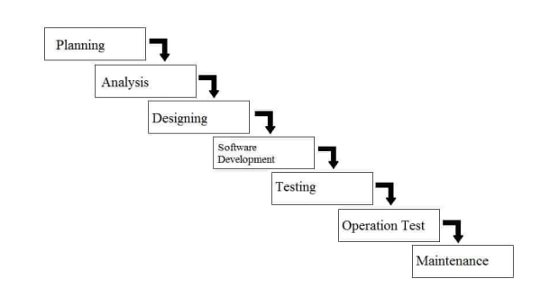
Figure 5. 1 Waterfall Model

This system is based on Waterfall Model for the System Development Life Cycle (SDLC), because this model gave lot of advantage including; in each stage and activity done in development of the project, those stages and activities were easily explained and also in each verification and review of each stage can easily locate and repair errors that may occur in the program

5.3 Functional and Non-functional Requirement Specification

5.3.1 Functional Requirement Specification

For Admin Module Features:
- Admin Dashboard
- Can manage category
- Manage author
- Book Management
- Admin can issue a new book to a student
- Update the details when the student returns the book
- Search student by using their student ID
- View student details
- Change own password

For Students Module Features:
- Register yourself and after registration; they will get student id
- Student can view the dashboard,
- Update personal profile,
- View issued book and book return date-time.
- Change their password, and
- Recover personal password.

5.3.2 Non- functional Requirement Specification
- System should be reliable and secure.
- System should be user-friendly.
- System should not take large memory and should be fast.
- System should have verification of email and password.

6. Software Development

6.1 Use case Diagram
A use case diagram is a visual representation of the interactions between actors (users or external systems) and the system being analyzed. It illustrates the functionalities or actions that can be performed by various actors within a system.
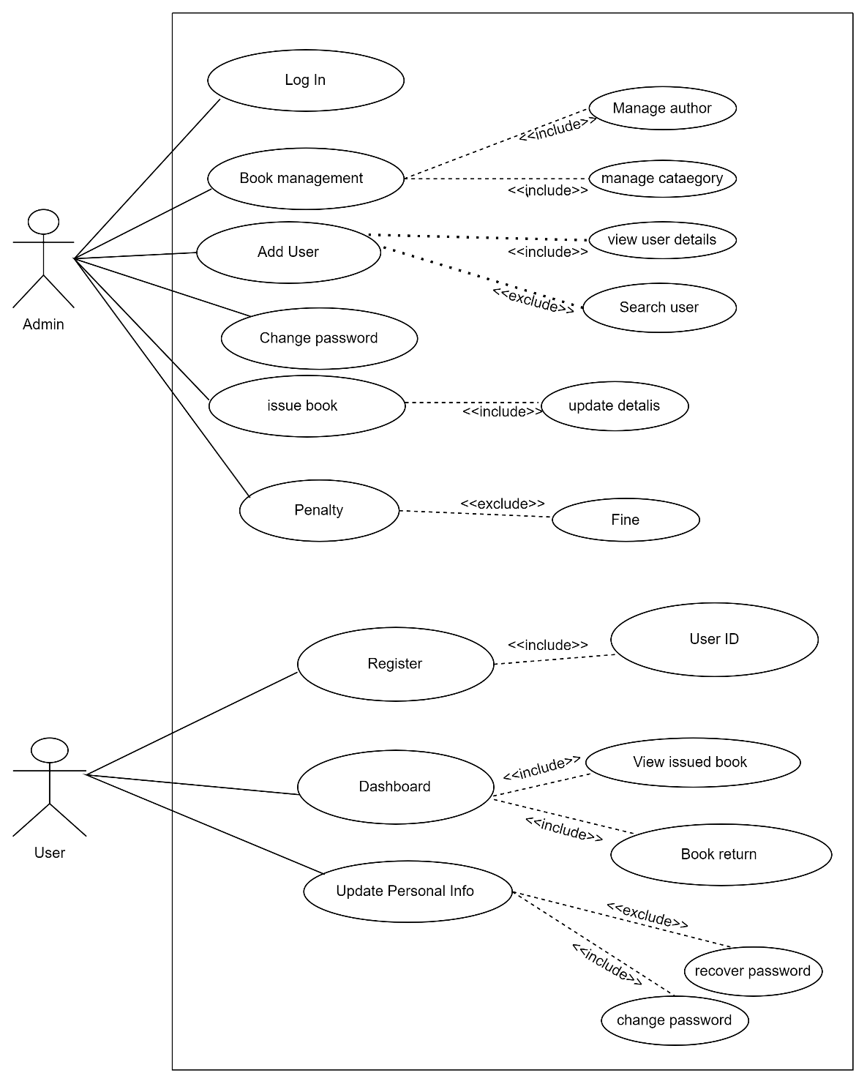
Figure 6. 1: Use Case

Use case Diagram Description
In the above diagram in user side, users are able to register if they are new user and old user can directly log in. After logging in they can view dashboard, their personal information, and update the data. In admin side, they can login and manage the books. Admin can add user, change password, issue book to user and can take penalties to those who returns book lately.

6.2 Activity Diagram
An activity diagram visually presents a series of actions or flow of control in a system similar to a flowchart or a data flow diagram. They can also describe the steps in a use case diagram. Activities modeled can be sequential and concurrent. Activity diagram is another important behavioral diagram in UML diagram to describe dynamic aspects of the system.

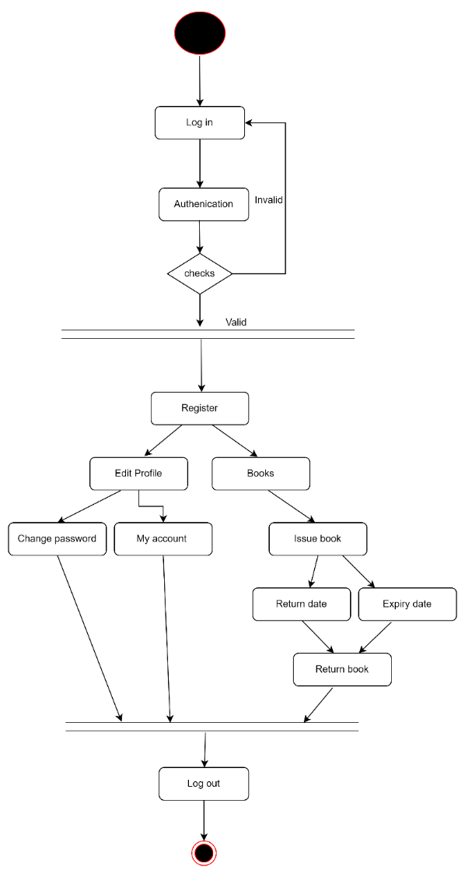
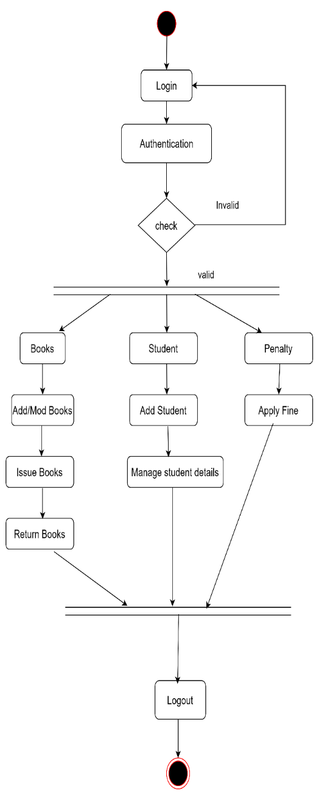

Figure 6. 2: Activity Diagram
Admin side User side

Activity Diagram Description
In the above diagram in user side, users are able to register if they are new user and old user can directly log in. After logging in they can edit their profile, and issue a book. In admin side, they can login and manage the books. Admin can add user, change password, issue book to user and can take penalties to those who returns book lately.

6.3 Sequence Diagram
A sequence diagram is a type of UML (Unified Modeling Language) diagram that illustrates the interactions and behavior between objects or components in a system over time. It is used to model the behavior of a system or process and is particularly useful in modeling complex interactions between objects or components. A sequence diagram consists of objects, messages, and lifelines.
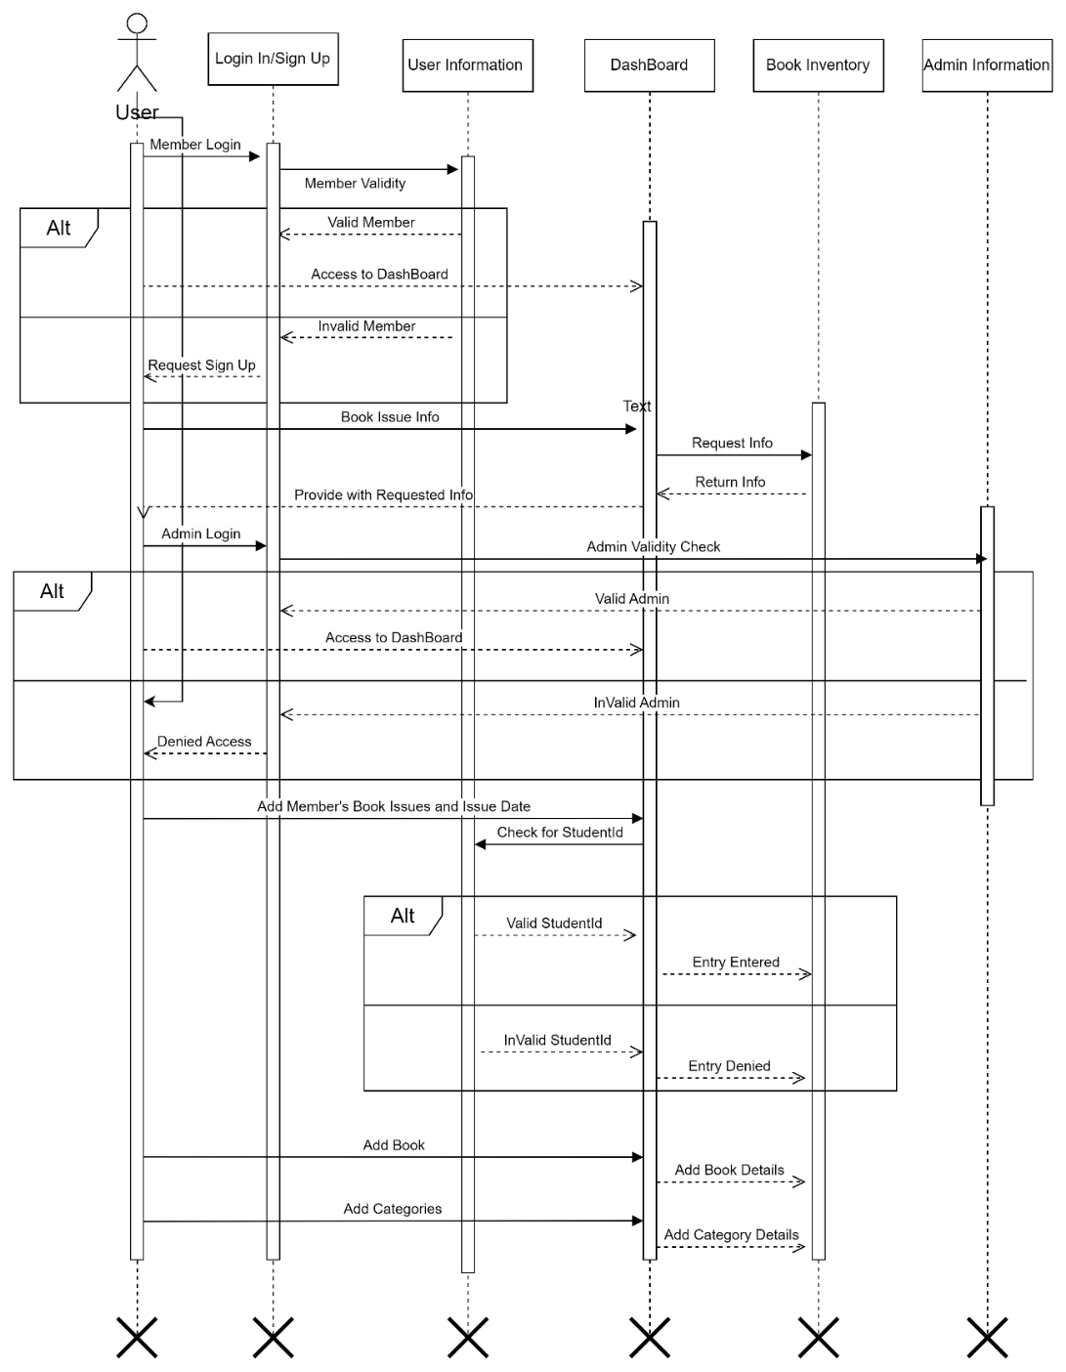
Figure 6. 3: Sequence Diagram

Sequence Diagram Description
This sequence diagram provides an overview of the interactions between the user and the Library Management System. It showcases the steps involved in logging in, browsing and searching for books, reserving, borrowing, returning, renewing books, and logging out.

6.4 State Diagram
A State diagram is visual representation of the states an object or system can be in and the transitions between those states. It is often used in software engineering, control engineering and other fields to model the behavior of system. A State diagram consist of a set of states represented by rounded rectangle, circles or ovals, and transitions between those states, represented by arrows.

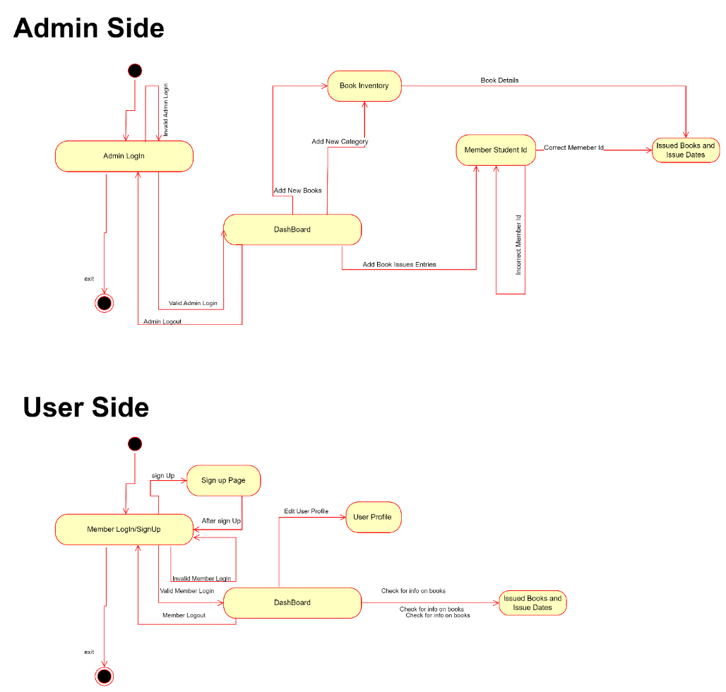
Figure 6. 4 State Diagram

State diagram Description
On the user side of the library management system, the state diagram represents the different states a user can be in during their interaction with the system. Initially, the user is in the "Logged Out" state, where they have not yet logged in. From this state, they can transition to the "Logged In" state by providing valid credentials. Once logged in, the user can check information about their borrowed book, and accessing their account information. The user can navigate between these states based on their actions and the system responses, ultimately returning to the "Logged Out" state when they log out of the system.

On the admin side of the library management system, the state diagram illustrates the different states an admin can be in while managing the system. Initially, the admin is in the "Logged Out" state, similar to the user side. From this state, they can transition to the "Logged In" state by providing valid credentials. Once logged in, the admin can perform various actions such as managing books, managing authors, managing users, generating reports, and configuring system settings. These actions are represented as transitions between different states, such as "Manage Books,", "Manage Authors", "Manage Users," "Generate Reports," and "Configure Settings." The admin can move between these states based on their actions and the system responses, and they can log out of the system to return to the "Logged Out" state. This state diagram showcases the flow of activities and states that an admin encounters while managing the library management system.

6.5 Data-Flow Diagram

A data flow diagram (DFD) is a graphical representation of a system or process that shows the flow of data through it. It is a modeling technique that allows you to visualize how data moves between processes, data stores, and external entities. A DFD typically consists of four components: processes, data flows, data stores, and external entities.
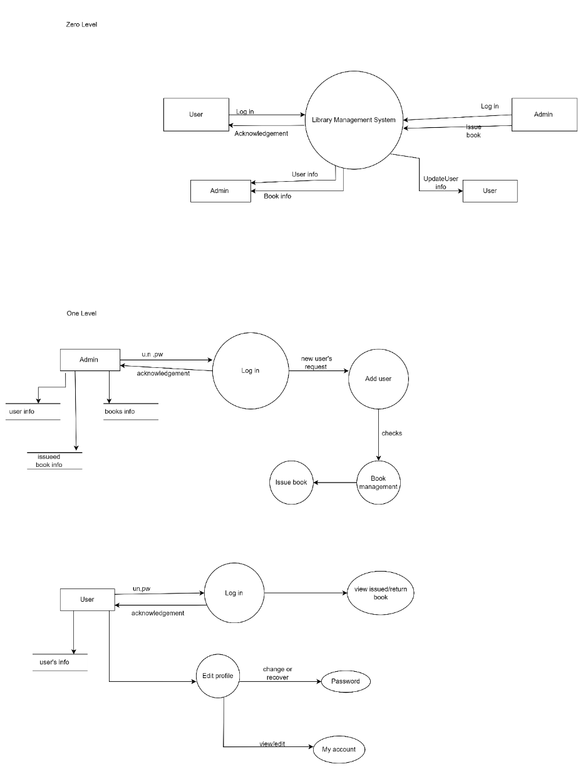

Figure 6. 5 Data Flow Diagram

7. Database design

7.1 ER Diagram
An Entity-Relationship (ER) diagram is a visual representation that depicts the relationships among entities in a database. It is commonly used in database design to illustrate the structure and organization of data, as well as the relationships between different entities. An ER diagram helps visualize the database structure and relationships, making it easier to understand and design databases. It serves as a communication tool between stakeholders, database designers, and developers, ensuring a clear understanding of the data model and database requirements.

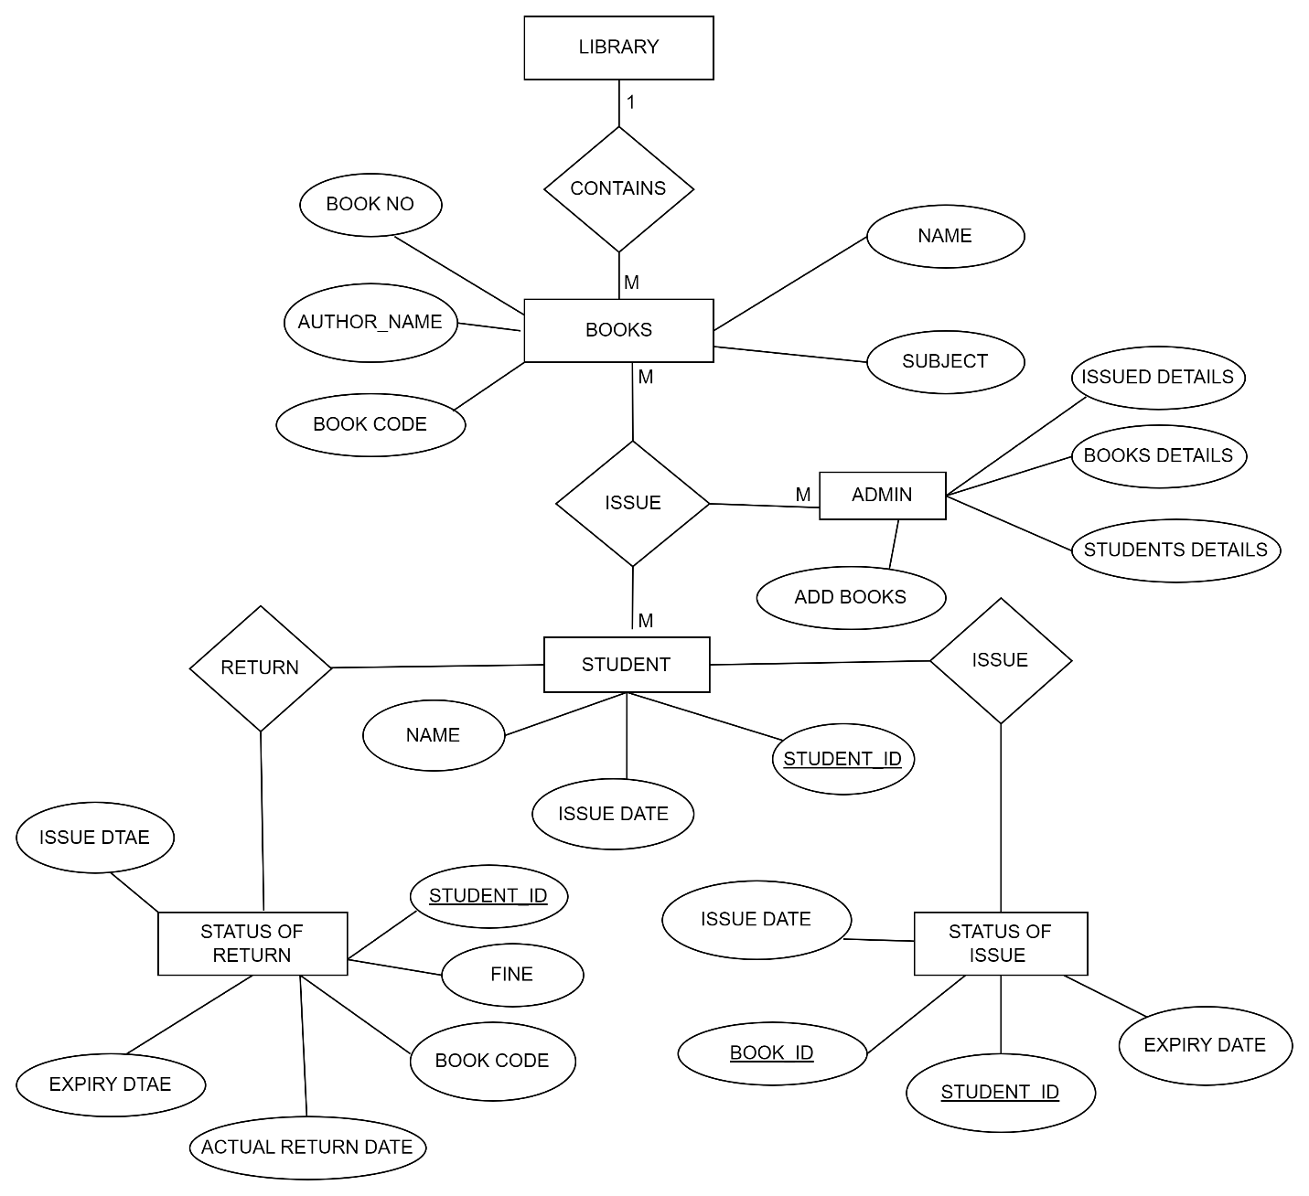
Figure 7. 1 ER Diagram

ER Diagram Description
The primary entities in the diagram are "Book", "Students" and "Status of Return", "Status of Issues". The "Book" entity represents the books available in the library, with attributes such as book No, Author Name, name, and subject and book code. The "Student" entity represents library members, with attributes like student ID, name, issue date.
The relationship between "Book" and "Students" is represented by the "State of Return " entity and "State of Issue" entity. The "State of Issue " entity captures the borrowing of books by members, with attributes such as Book ID, student ID, issue date, and expiry date. The "State of Return " entity captures the returning of books by members, with attributes such as book code, student ID, issue date, and actual return date, fine and expiry date. This relationship illustrates that a member can borrow books, and return with in before the expiry date to no get fined.
The ER diagram visually represents the relationships and attributes of the entities in the Library Management System, providing a clear overview of how the different components interact with each other.

7.2 Data dictionary

Figure 7. 2 Admin Information
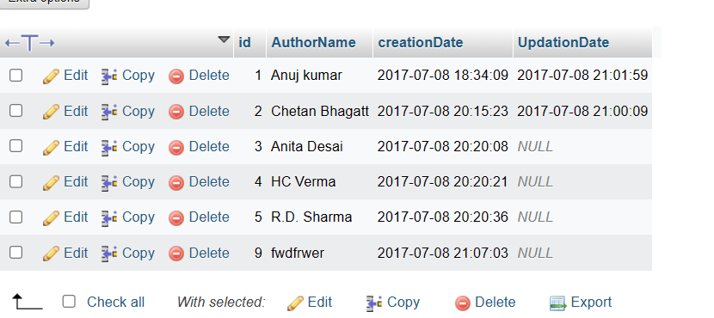
Figure 7. 3 Author Information

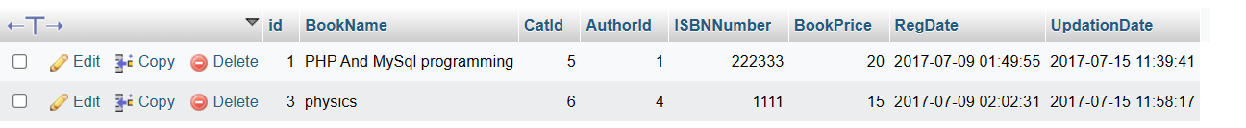
Figure 7. 4: Book Information

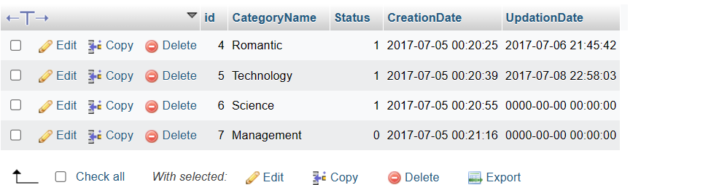

Figure 7. 5 Category Information

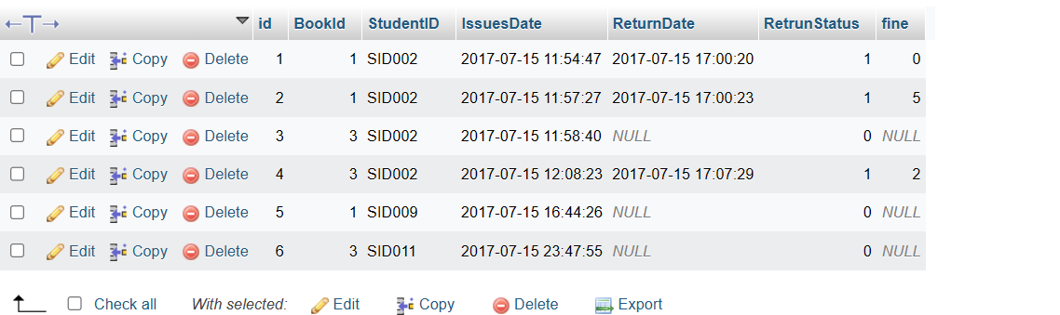
Figure 7. 6 Issued Books Details

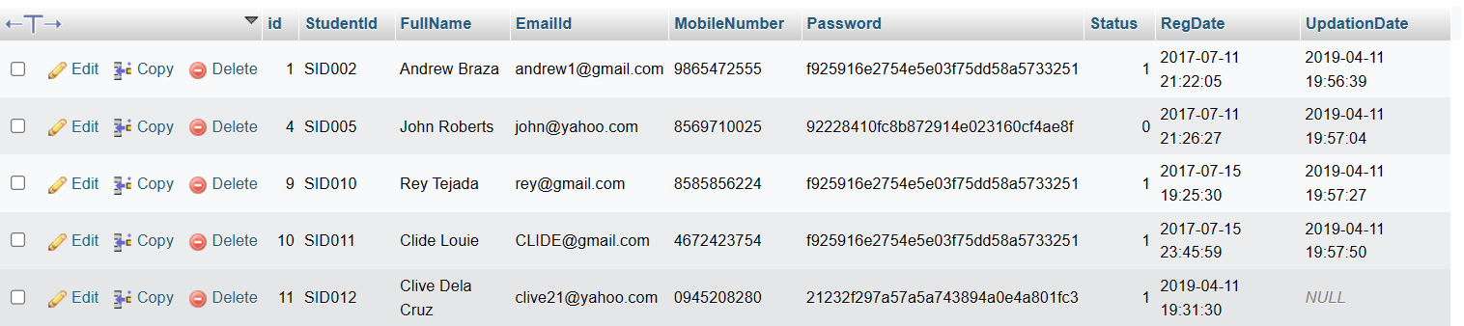
Figure 7. 6 Student Details

8. Gantt Chart
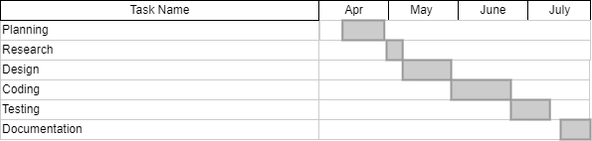
Figure 8. 1 Gantt Chart

9. Implementation of code:

- PHP
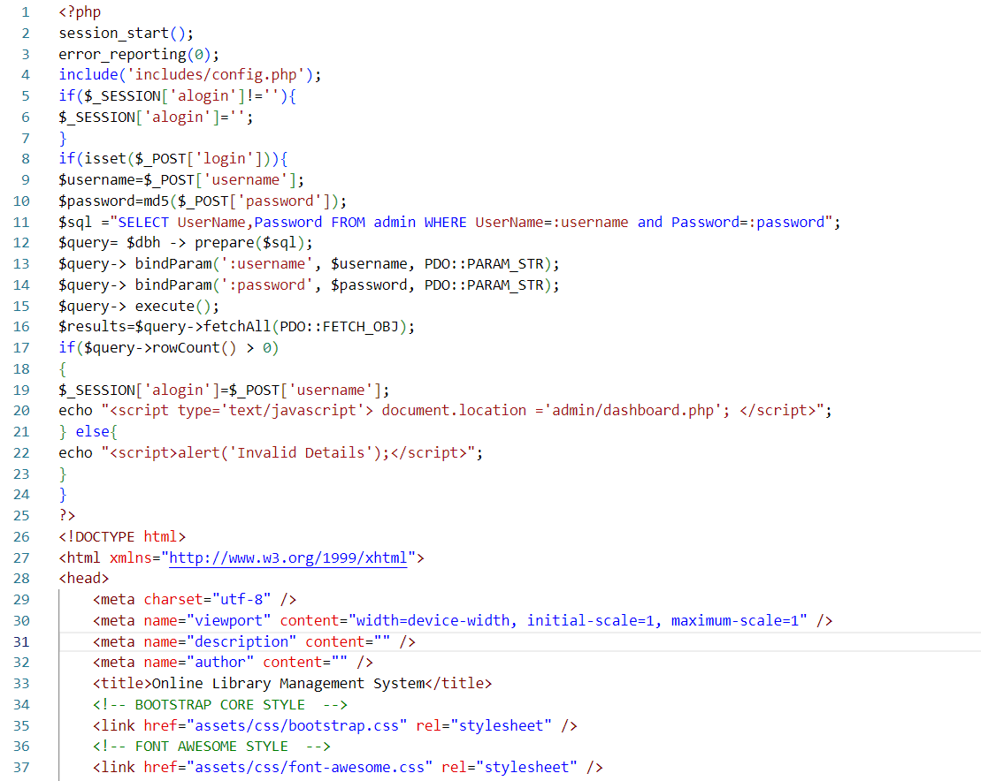

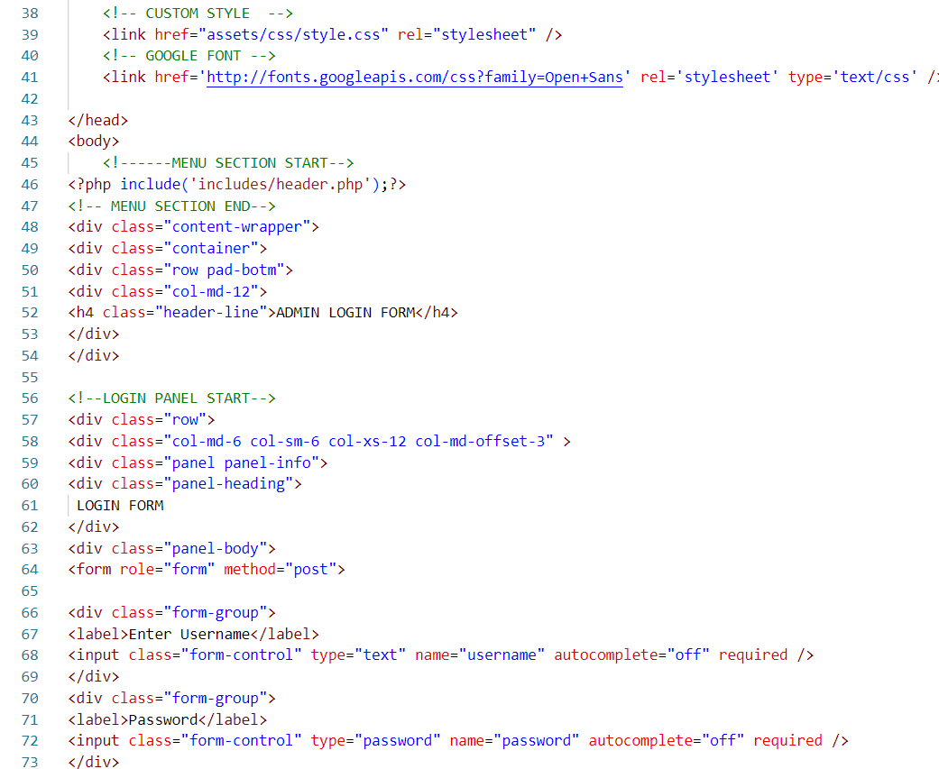

- CSS 3. JS
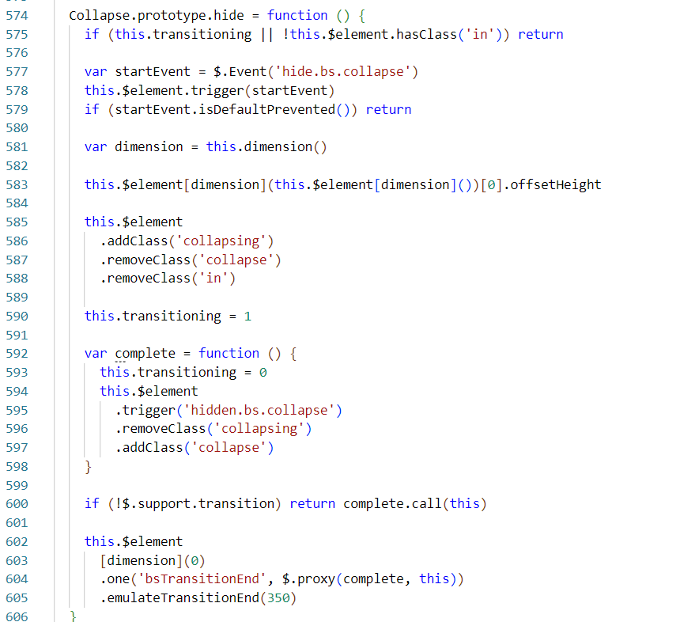
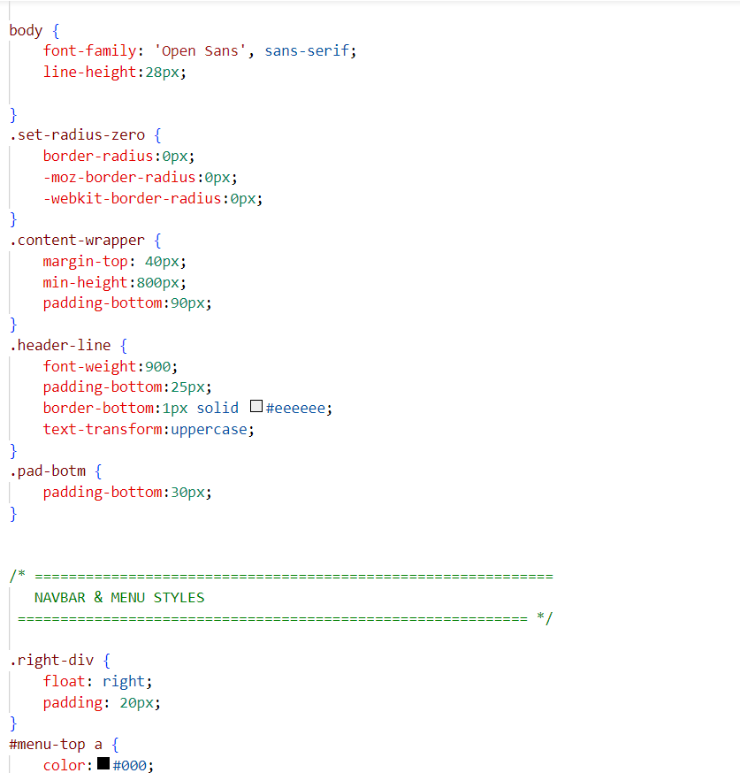

10. Screenshots:

- Admin Side

Figure 9. 1: Admin DashBoard

Figure 9. 2: Authors

Figure 9. 3 : Book Managing

Figure 9. 4: Categories

Figure 9. 5: Issues Books

Figure 9. 6 Students Information

10. Conclusion

In conclusion, the implementation of the library management system has greatly enhanced the efficiency and effectiveness of library operations. This system has also provided a user-friendly interface, allowing users to easily search and access library resources, promoting a seamless and enjoyable experience. Overall, this library management system has proven to be an indispensable tool for modern libraries, enhancing accessibility, organization, and ultimately, the overall user experience.

References
Patulada, M. G. (2023, 07 06). ITSOURCECODE. Retrieved from Library-Borrowing-System-Documentation: https://itsourcecode.com/wp-content/uploads/2022/03/Library-Borrowing-System-Documentation.pdf

